Henry Lankin

Gui Larangeira

January 17, 2017

STAT 6305

Dr. Zhou

HW 1: 14.1, 14.5, 14.7, 14.16

14.1

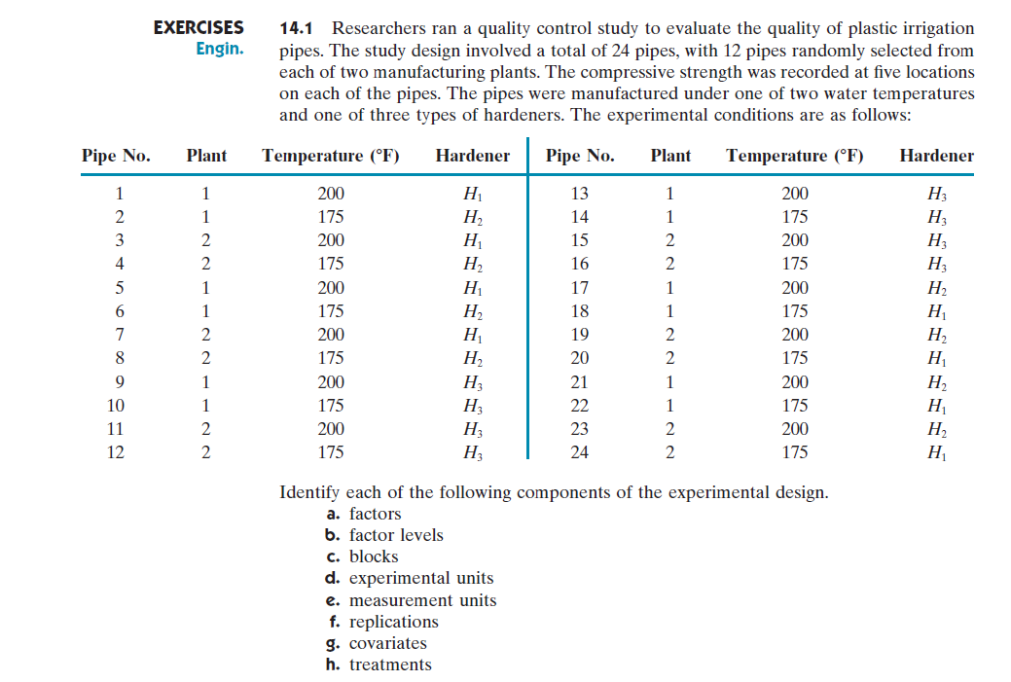

1. 3 factors: Plant, Temperature ($℉$), Hardener
2. Plant has 2 levels: Plant 1, Plant 2

Temperature has 2 factor levels: $175, 200$

Hardener has 3 factor levels: $H_{1}, H_{2},H_{3}$

1. Blocks: none
2. Experimental units: 24 pipes
3. Measurement units: 5 locations measured on each of the 24 pipes totaling 120 measurement units
4. 2 replications: 2 for each combination of plant, temperature, and hardener
5. Covariates: could be thickness, weight, and length of each pipe
6. Treatments: 12 treatments listed in the table below

|  |  |  |  |  |
| --- | --- | --- | --- | --- |
| Treatment | Plant | Temperature | Hardener | Replications |
| $$1$$ | $$1$$ | $$175$$ | $$H_{1}$$ | pipes 18, 22 |
| $$2$$ | $$1$$ | $$200$$ | $$H_{1}$$ | pipes 1, 5 |
| $$3$$ | $$2$$ | $$175$$ | $$H_{1}$$ | pipes 20, 24 |
| $$4$$ | $$2$$ | $$200$$ | $$H_{1}$$ | pipes 3, 7 |
| $$5$$ | $$1$$ | $$175$$ | $$H_{2}$$ | pipes 2, 6 |
| $$6$$ | $$1$$ | $$200$$ | $$H_{2}$$ | pipes 17, 21 |
| $$7$$ | $$2$$ | $$175$$ | $$H_{2}$$ | pipes 4, 8 |
| $$8$$ | $$2$$ | $$200$$ | $$H_{2}$$ | pipes 19, 23 |
| $$9$$ | $$1$$ | $$175$$ | $$H_{3}$$ | pipes 10, 14 |
| $$10$$ | $$1$$ | $$200$$ | $$H_{3}$$ | pipes 9, 13 |
| $$11$$ | $$2$$ | $$175$$ | $$H_{3}$$ | pipes 12, 16 |
| $$12$$ | $$2$$ | $$200$$ | $$H_{3}$$ | pipes 11, 15 |

14.5

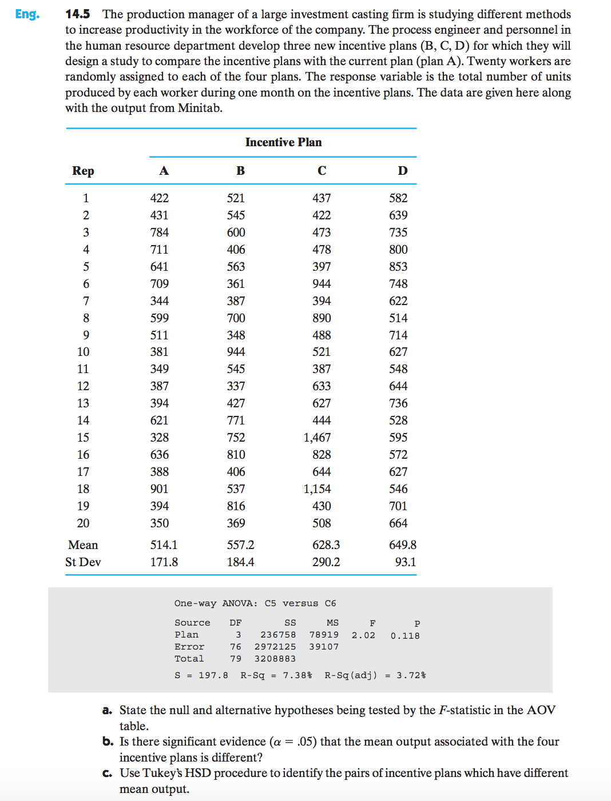

1. Hypotheses being tested:

$$H_{0}:μ_{A}=μ_{B}=μ_{C}=μ_{D}$$

$$H_{a}:At least one of the population mean units produced$$

$under a plan differs from the others$

1. No, there is not significant evidence that at least one is different from the others since the $p$-value $=0.118>0.05$.
2. Use Fisher’s LSD procedure to identify the pairs of incentive plans which have different mean output.

# given information about the experiment

n <- 20

alpha <- 0.05

# point estimates of the means

incentive.means <- c(514.1, 557.2, 628.3, 649.8)

# from ANOVA output

MSE <- 39107

df.errors <- 76

# Fisher's LSD procedure

sd.errors <- sqrt(MSE)

t.value <- qt(alpha/2, df.errors, lower.tail = FALSE)

LSD <- t.value*sd.errors*sqrt(2/n)

[1] "LSD = 124.550421"

diffCombn.matrix <- combn(incentive.means, 2)

means.diff <- diffCombn.matrix[2,] - diffCombn.matrix[1,]

[1] "Pairs to subtract listed for each possible combination by column:"

[,1] [,2] [,3] [,4] [,5] [,6]

[1,] 514.1 514.1 514.1 557.2 557.2 628.3

[2,] 557.2 628.3 649.8 628.3 649.8 649.8

[1] "Differences for each pair in relative order to the matrix above:"

[1] 43.1 114.2 135.7 71.1 92.6 21.5

We see that only the difference between plan d and plan a, ${\overline{x}}_{D}-{\overline{x}}_{A}=135.7$, is larger than the LSD, $LSD=124.6$. But, since $H_{0}$ was not rejected in part b, the LSD procedure would not be performed. If we ignored the result of the hypothesis test, the LSD procedure would imply that there is a significant difference between plans A and D.

14.7

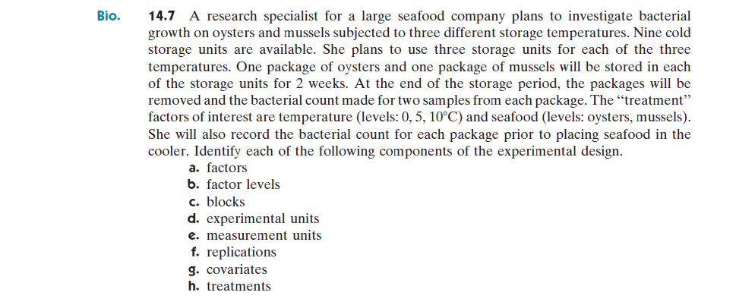

1. 2 factors: temperature, seafood
2. Temperature has 3 factor levels: $0, 5, 10℃$

Seafood has 2 factor levels: oysters, mussels

1. Blocks: none
2. Experimental units: the package of oysters and package of mussels in each of the 9 storage containers
3. Measurement units: the 2 samples taken from each package, totaling 36 measurement units
4. 3 Replications: Each treatment will be applied in three different storage containers
5. Covariates: the bacterial count in each package prior to performing the experiment, the weight of each package of seafood, number of oysters and mussels in each package
6. 6 treatments: (oyster, 0), (oyster, 5), (oyster 10), (mussel, 0), (mussel, 5), (mussel, 10)

14.16

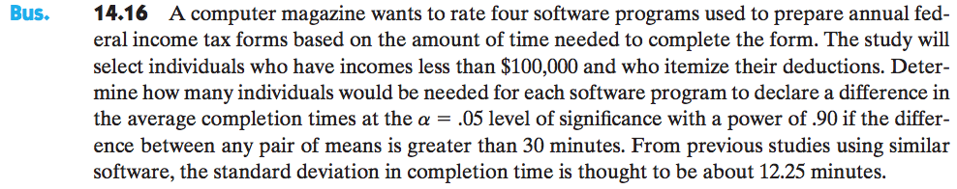

Given information:

$$α=0.05, β=0.10, t=4$$

$$D=30, \hat{σ}=12.25$$

The desired power is $Power=1-β$. We first obtain the parameters to use in Table 14 from the textbook,

$$ϕ=\sqrt{\frac{rD^{2}}{2t{\hat{σ}}^{2}}}=\sqrt{\frac{r{\left(30\right)}^{2}}{2\left(4\right){\left(12.25\right)}^{2}}}$$

$$ϕ=0.866\sqrt{r}$$

and,

$$v_{1}=t-1=4-1=3$$

$$v_{2}=t\left(r-1\right)=4(r-1)$$

By trial and error, we get the following table,

|  |  |  |  |
| --- | --- | --- | --- |
| $$r$$ | $$v_{2}=4(r-1)$$ | $$ϕ=0.866\sqrt{r}$$ | $$Power=1-β$$ |
| 3 | 8 | 1.50 | 0.48 |
| 7 | 24 | 2.29 | 0.97 |
| 5 | 16 | 1.94 | 0.84 |
| 6 | 20 | 2.12 | 0.90 |

## Alternative method: calculating the power table values using R

# values of replications to test

r <-c(3, 7, 5, 6)

# degrees of freedom for F-dist

v.1 <- t-1

v.2 <- t*(r-1)

df.1 <- v.1

df.2 <- v.2

# We use the non-centrality parameter of the F-distribution instead of the psi parameter of the book

ncp <- r*D^2/(2*sd^2)

F.alpha <- qf(1-alpha, df.1, df.2)

# The power is P(F > F(alpha, t−1,t(r−1),ncp))

power <- 1- pf(F.alpha, df.1, df.2, ncp = ncp)

# Form the table as a data.frame

phi.value <- sqrt(ncp)

table.power <- data.frame(r, v.2, phi.value, power)

r v.2 ncp power

3 8 8.996252 0.4869220

7 24 20.991254 0.9567155

5 16 14.993753 0.8301800

6 20 17.992503 0.9120138

From the chart above, we see that with a minimum of 6 replications the desired power of the test, $power=0.90$, will be most closely attained.